TUG SHENANDOAH
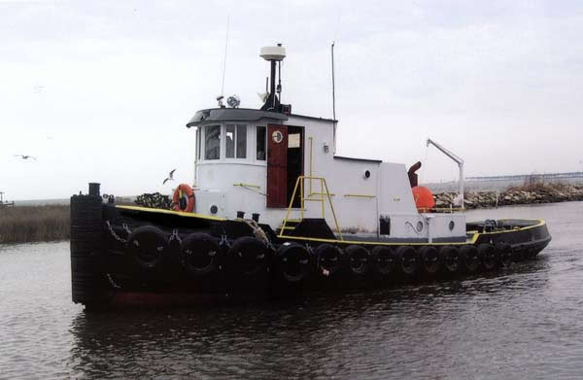

Length | Breadth | Depth | Gross Tons | Net Tons
49 feet | 16 feet | 5.5 feet | 29 tons | 20 tons

Horsepower | Fuel Capacity | Range
520 | 900 gallons | 850 miles

The Shenandoah is an economical, highly efficient tug. Her power allows her to work with barges and vessels that most tugs her size couldn’t handle.

Her short length, low profile and shallow draft combined with 520 hp driving a 48” propeller give her the ability to work in tight areas and other places where larger tugs can not work. Her crew’s quarters allow us to stay on station for extended periods of time and our state of the art, computerized wheelhouse allow for advanced navigation and station keeping, as well as internet connectivity to your job site. She is fully-insured, the captain and crew are properly licensed and enrolled in a random drug-testing program and the Shenandoah has been inspected by the US Coast Guard.

We pride ourselves on our Can-Do attitude. We have been at this a long time: Tugs and barges are our lives. Let us show you a truly dedicated, professional marine services company in action. You won't be sorry.

