STANDARD OPERATING PROCEDURES
TOWING

ALONGSIDE
- Before making up to the barge, find out where it will end up. This will help determine which side you should make up to for a more controlled landing at your destination.
- Check the weather. If you have a short run and need to be alongside, determine which side will be the lee side. It will be more comfortable for the crew and will lessen surging between tug and barge on the lee side.
- The tug secures to one side of the tow with her own stern abaft of the stern of the tow. This will increase the effect of the tug’s screw and rudder. The side chosen depends on how much the tug must maneuver with the tow.
- If all turns are to be made with the tug’s screw going ahead, she will be more favorably placed on the outboard side of the tow--the side away from the direction toward which the most turns are to be made.
- If a sharp and difficult turn is to be made under headway, the tug should be on the side toward which the turn is to be made. Here she is properly placed for backing to assist the turn, because as she slows, the tow’s bow will turn toward the side the tug is on.
- If a turn is to be made under no headway, the tug is more efficient on the starboard side of the tow. When the tug backs to turn, the port send (side force) of her screw will combine with the drag of the tow to produce a turning effect greater than that which could be obtained with the tug on the port side.
- The best position for a long back in a straight line is to have the tug on the port side. Then the drag of the tow tends to offset the port send of the backing screw.
- As you come alongside, the deckhand should be preparing to put out a spring line.
- Once the spring line is secured, angle the bow in and make up the head (bow) line. The bowline or backing line is paid out over the outboard side of the bow stem or king post and lead to a bitt on the forward end of the tow. Once the bowline is secured on the tow, all the slack is taken in and the bowline secured. This will bring the tug into proper position, slightly bow-in to the tow. When backing down, the bowline becomes the towline.
- Once the bow line is secured bring the stern in and make up the stern line. The stern line or turning line is lead from the tug’s stern to the outboard side of the tow’s stern. The purpose of this line is to keep the tug’s stern from drifting out. The three lines, when properly secured and made taut, will make the tug and tow work as one unit.
- It will be necessary to work up as hard as practical (up to 1450 rpm’s) to get the stern line tight. Make sure that you are against a pier that can handle the tug working up hard on the barge. Also, watch your wheel wash. If the lines are great between the barge and pier, or if other factors won’t allow you to work up hard then make it up as tight as you can then once out in open water off the pier, work her hard over (stern to barge) and tighten the line.
- If taking the barge alongside in open water (not against a wall or pier) make sure that you have sufficient room to turn a full circle as you put out and tighten lines. This includes room around all piers, docks, marinas, shorelines, etc and other vessels.
- The diagram below will show you how you should ideally be made up. The bow breast line is usually not necessary, but you can use it if you feel that your bow is to far out (usually because the lead on the bow line is long).
- It is usually a good practice to double up on your spring line and bow line. You can also double up the stern line. It will provide a better ride and piece of mind.

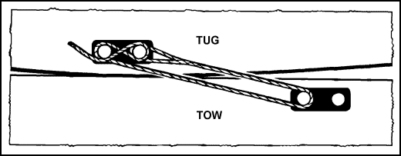

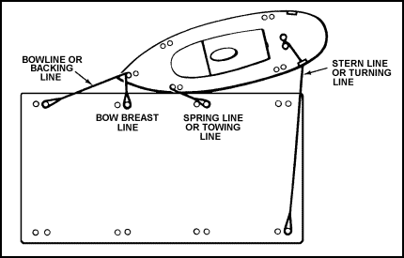

- You may find yourself with two barges. If you have to pick them up at a pier and they are side by side, nose between them after you have taken off the stern line (line at your bow) between the barges. Leave the bows tied together. Make up as you would with a single barge. Get all lines between the tug and barges as tight as possible. Double up the line between the barges’ bows.

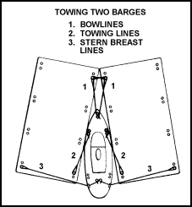

- Use chafing gear. If any of the lines lead over rough or sharp edges, put out chafing gear. This could be fire hose or rug wrapped around the line or wood placed under the lines at the wear points.
- Don’t forget the barge lights both putting them out and taking them in.
- Occasionally, it will be necessary to shift from one side of the tow to the other. You can let the barge go completely if you have enough sea room, or you can keep lines out as shown in the following diagram:
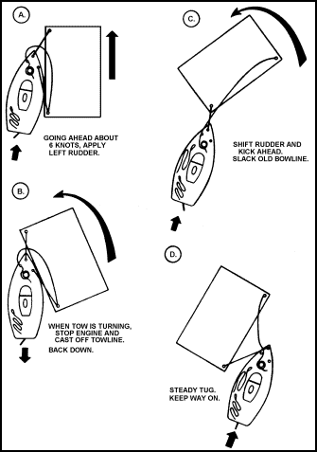

WARNING:
1. When securing these towlines, remember; NEVER secure the line so that it cannot be thrown off quickly and easily.
2. Areas of the harbor subject to wave action should be avoided whenever possible. The tug and tow seldom pitch in the same tempo. When both start pitching out of harmony, the lines take a heavy strain and may part. When equipped with a rudder the tow assists in steering. Size and loading of the tow may obstruct the view of the tug’s conning officer. In that case, a lookout is stationed aboard the top who keeps the conning officer fully informed of activity and hazards in the blind area.

PUSHING
- Before making up to the barge, find out where it will end up. This will help in determining which end to push from. The contractor may want the crane end forward and the crane may be on the stern of the barge. If your destination is a narrow space, you may not have room to spin the barge and put the crane end where they want it. Ask first!
- Check the weather. Do not push in seas over 2 feet.
- As you come up to the barge, the deckhand must get your head line(s) out first.
- On barges without a center bitt/cleat, run a line to each side from the tug’s stem.
- Put out the safety lines next from the tug’s forward quarter bitts to the barge’s corners.
- Put out the push wires last. Make sure the tug is centered and straight for maximum steering.
- If you know that you are going to handle the same barge later, when breaking down, slack one wire and then when you make up again, put that wire out first (after the head and safety lines).
- Don’t forget the barge lights both putting them out and taking them in.

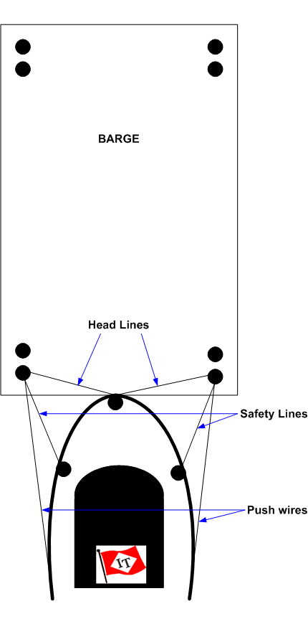

ASTERN
- You will generally tow astern because the weather will not permit you to tow alongside or push.
- Check the weather! The forecast will help you determine how much hawser to put out.
- Unless towing on gate lines, you want the barge away from the tug’s stern. The tug’s wheel wash will have an effect on the tow. It will try to push the barge backwards. Get the tow out of your wheel wash.
- Gate lines are for towing short with the maximum steerage. You will take two lines and run them out to the barge. One on each corner and then bring them back to the tug’s stern quarter bitts. You can lead them around the bitts and make up on the H-Bitt if it is easier for you. The lines must be of equal length when made up. Ideally, you will almost be able to step off of the tug’s stern onto the barge when made up.
- Use chafing gear. The Shenandoah has a hawser board to minimize chafing of the hawser on the tug’s stern. Also, if the barge has sharp edges, use chafing gear on the bridles or shackle the bridles into chain or cable donuts that are looped over the bitts and lead over the sharp/rough edge.
- Old fire hose cut into 4- to 6-foot lengths and then split lengthwise makes excellent chafing gear. It is wrapped around the hawser or towing cable to protect it from wear due to constant rubbing.

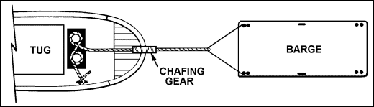

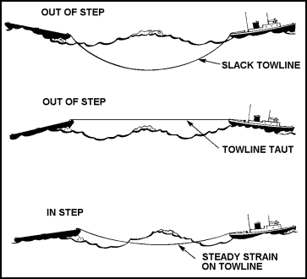

- Hawser length will be determined by the sea! Barge and tug must be in step. Too much line out could cause the towline to foul on the bottom. Too little line out will cause the line to jump out of the water. This puts too much strain on the line.
- The scope of a hawser should be long enough to provide a good catenary, but not to the extent of having the towline drag on the bottom if in shallow water. A catenary absorbs shocks. You should not put stress on a towline to the extent of lifting it out of the water, but you can increase the catenary by reducing the tug’s speed.
- Towlines should never be made fast on the capstan.
- To rig a stern towline, the towing hawser should be faked out in the fantail of the tug. This will ensure that the hawser will pay out without becoming fouled.

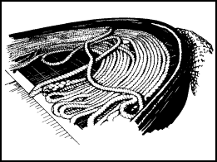
- The eye of the hawser is led back over the top of the "H" bitt, over the shoulder of the horn, and back through the legs of the bitt. Then the hawser is payed out. When you get close to the point where you are going to secure the tow, take a full round turn and cross the line back onto itself. Then take two or three additional round turns before you figure eight the line on the bitts, and finish it off with two or three turns on the arm of the bitt.

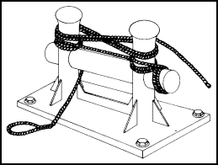

- Shifting usually is necessary when a tug is to tow a barge from port to port. The tow is taken alongside within the harbor and shifted astern outside. The shifting procedure is simple. The towing hawser is connected to the towing bridle before getting underway. Outside the harbor, the lines used for towing alongside are cast off, allowing the tow to drift away from the tug. Then, by slowly accelerating and carefully altering course and judiciously paying out the towing hawser, the tug gets underway with the tow and comes to the required course.
- Note: When towing astern, you have limited control over the forward motion and turning of the tow. For this reason, stern tows are made in open waters. The longer the towline the less control you will have.
- Note: Before assembling the towing rig, the mate and boatswain will inspect each item of equipment. If there is any doubt of its serviceability, REPLACE IT! If there is a question of size, for safety’s sake, go to the next larger size. Remember, if anyone of these items fail you at sea, you stand the chance of losing the tow and even the life of a crew member.
- Note: A hawser watch must be posted on the after deck to keep tow and gear under constant observation. Instruct the crew member, on watch, to immediately report the following:
  - Too much tension is on the towline.
  - The tow is not weathering properly.
  - The bridles or other gear fail.
- In addition to chafing gear, continued monitoring of the towline’s condition is necessary and important. Stern rollers and other fairleads must be properly lubricated and all possible points of line wear offered a fairlead. Canvas, hose, line, wood, or other materials should be used for chafing gear as required. Chafe must be eliminated or reduced on board the tow and the tug as much as possible. Continued paying out and retrieving of the towline can cause excessive chafing. Freshening the nip and lengthening or shortening the tow wire should be done every few hours in moderate weather and more often during heavy seas.
- The towline must be checked periodically for a fairlead and chafing. Points of chafe must be protected. Appropriate lubrication and wearing surfaces should be placed so as to eliminate towline-to-hull contact.

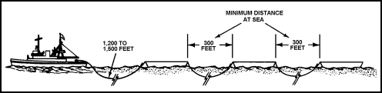
Tandem Tow Make-up
- When towing more than one barge astern, it is referred to as tandem towing. In a pure sense, tandem means one behind the other.
- In this method, the tug is connected to the first tow. The first tow connects to the second, and so on if additional units are towed. The intermediate hawser, connecting the first tow to the second, must be streamed and allowed a proper catenary depth. The surging action must be eliminated between tug and first tow and between first tow and second tow.

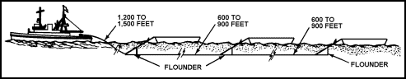
Honolulu Tow Make-up
- In this method, the first tow is connected to the main tow wire. The second tow is connected, with an auxiliary tow wire, to the bitts on deck. The Honolulu rig allows independent connection of the two tows. Disconnecting and control are readily workable.

WARNINGS:
1. Always face your work.
2. Never step over a line that is laying on the deck. Either lift it up and walk under it, or step on top of it and cross over. Never straddle or step in the bight of a line.
3. When towlines are coming under or are under a strain, work fast. Get the turns or figure eights on a quickly as possible. When surging or slacking off on a line that is under strain, Keep your hands clear of the bitts.
4. Know where the fire axe is located.
5. The greatest danger in using towlines is that if the line should part when under strain, it will snap back its full length like a bull whip. The force of the snapback is tremendous depending on the strain that the line was under at the time it parted. There is no set pattern on how the line will whip back. It may snap back directly on itself or it may whip from side to side. There is no way to tell what it will do. If you see a synthetic fiber line under strain parting or beginning to part--DO NOT RUN--just fall flat down on the deck.

LIGHTS

Inland |  | International
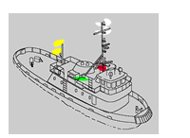  Power-driven vessel pushing ahead or towing alongside - towing vessel less than 50 meters in length. |  | 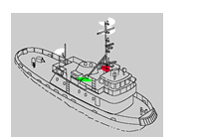  Power-driven vessel pushing ahead or towing alongside - towing vessel less than 50 meters in length.

